Day 13-NoSQL

Mini project
- Employee collection
- Insert 50 records
- perform:
  - Salary analysis

This query groups all employees (_id: null) to calculate average, minimum, and maximum salary.

Query:

db.employee.aggregate([{$group:
{_id:null,
maxSalary:{$max:'$salary'},
MinSalary:{$min:'$salary'},
AvgSalary:{$avg:'$salary'}}
}])

Output:

{
_id: null,
maxSalary: 650000,
MinSalary: 20000,
AvgSalary: 208500
}

  - Department headcount

This query groups data based on department and returns counts of employees in each department.
Query:

db.employees.aggregate([
{$group: {
_id: "$department",
headCount: { $sum: 1 }
}}
])

Output:
{
_id: 'IT',
headCount: 12
}
{
_id: 'HR',
headCount: 10
}
{
_id: 'Finance',
headCount: 7
}
{
_id: 'Sales',
headCount: 9
}

  - Top 5 highest paid employees
This query returns the salary sorted descending in order to find top 5 employees who
paid highest.
Query:

db.employee.find().sort({salary:-1}).limit(5)

Output:

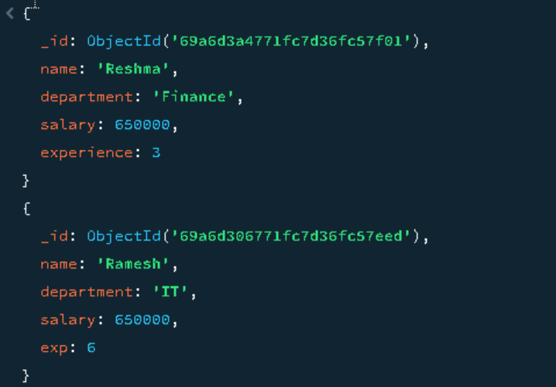

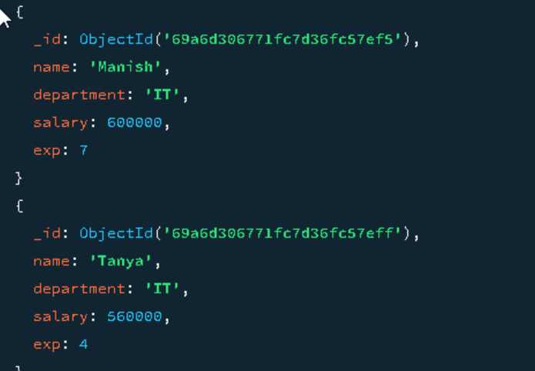
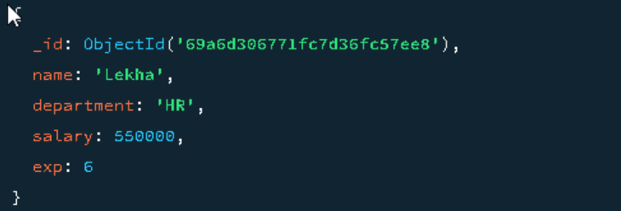

  - Create index on salary

Create an index using salary that useful for sorting based on salary descending.
Query:

db.employee.createIndex({salary:-1})

Output:

salary_-1
db.employee.getIndexes()
[
{ v: 2, key: { _id: 1 }, name: '_id_' },
{ v: 2, key: { salary: -1 }, name: 'salary_-1' }
]

  - Run aggregation pipeline

This query will return maximum salary based on experience.

Query:
db.employee.aggregate([
{
$group: {
_id:"$exp",
maxSalary: { $max: "$salary" }
}
},
{ $sort: { _id: 1 } }
])

Output:

{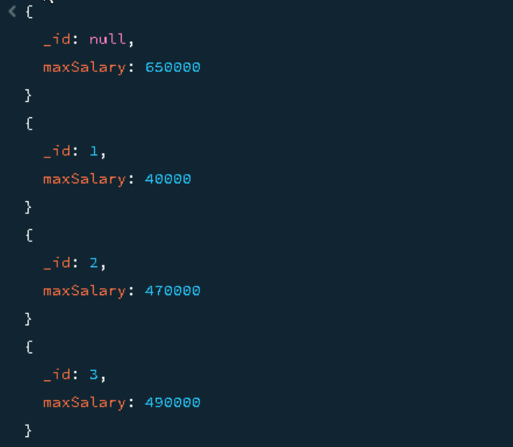
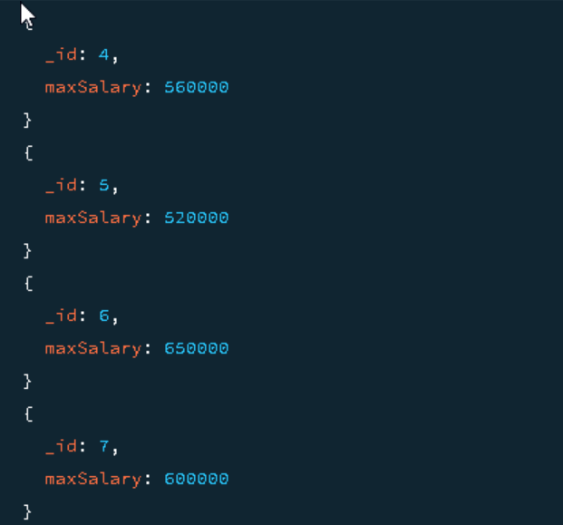
  - Total Salary Cost per Department

It will return Salary per department.
Query:

db.employees.aggregate([
{
$group: {
_id: "$department",
totalSalary: { $sum: "$salary" }
}
}
])

Output:
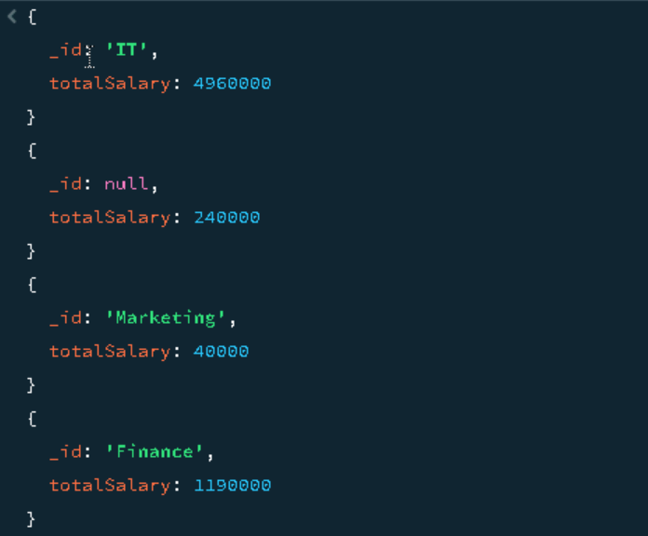
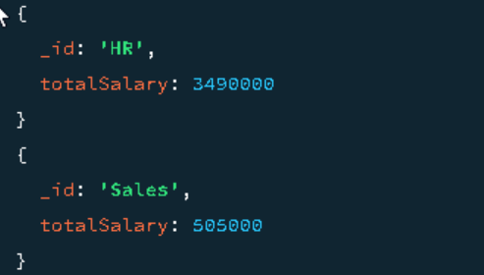

  - Highest paid employee in each department

It will return the highest paid employees per department.
Query:
db.employee.aggregate([
{ $sort: { salary: -1 } },
{
$group: {
_id: "$department",
topEmployee: { $first: "$name" },
topSalary: { $first: "$salary" }
}
}
])

Output:
